Department of Computer Science and Engineering

BRAC University

CSE 260: Digital Logic Design

Experiment # 8
Design and Implementation of the following circuit:
Four 2 bit numbers A, B, C, D and two selection variables S₁ and S₂ are available. S1 will select either A or B and S2 will select either C or D. Depending on the two selection variables, the circuit will work in the following way.

S1 | S2 | Operation
0 | 0 | A+C
0 | 1 | A+D
1 | 0 | B+C
1 | 1 | B+D
C₃ S₂ S₁
X₂ X₁ Y₂ Y₁
S₁
0 1
0 1
0 1
0 1

2:1

2:1

2:1

2:1
A₂ A₁ B₂ B₁ C₂ C₁ D₂ D₁
S₁
S₂
S₂

2 bit Parallel Adder
IC: MUX (74153) Adder: 7483
Report:

The report should cover the followings
- Name of the experiment
- Objective
- Required Components and Equipments
- Experimental Setup (i.e., diagram of the circuit)
- Results and Discussions
  - Draw a circuit diagram which will compare three 4 bit numbers. You have Magnitude Comparators and 2:1 MUXs.

Mux 74153

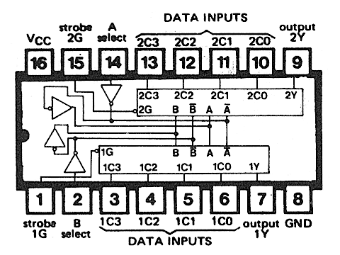

Adder 7483

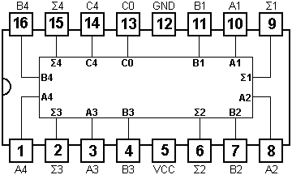

Set: C4 = C_{OUT,} C₀ =0
Strobe = Low

MUX Connection:

Make 4:2 Mux to 2:1 Mux in the following way

Short Selector A and B

Selector Data Input (Active) Output (1Y) Output (2Y)
00 1C0, 2C0 1C0 2C0
11 1C3, 2C3 1C3 2C3

Give Inputs:
B2

A2

First IC Connection: A = B= S1 (Selector)

1C0 → A1
A

2C0

2C3

1Y

1C3→ B1
MUX-1

2C0→ A2
2Y

1C3

1C0

2C3→ B2
B

S1

B1

A1

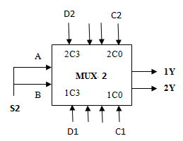
Second IC Connection: C = D = S2 (Selector)

1C0 → C1
1C3→ D1
2C0→ C2
2C3→ D2

Selector: S1  (First MUX) | OUTPUT of MUX-1 |  | Selector: S2  (Second MUX) | OUTPUT of MUX-2  1Y 2Y
Selector: S1  (First MUX) | 1Y | 2Y | Selector: S2  (Second MUX)
0 | A1 | A2 | 0 | C1 | C2
0 | A1 | A2 | 1 | D1 | D2
1 | B1 | B2 | 0 | C1 | C2
1 | B1 | B2 | 1 | D1 | D2

